CREATION OF WEB APPLICATION USING NODE RED

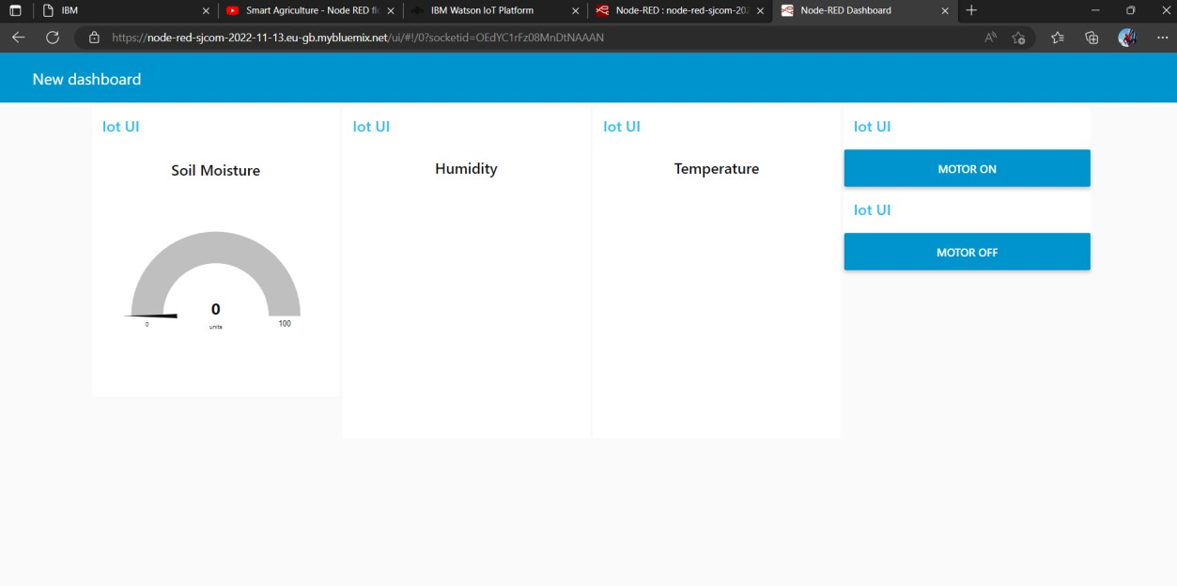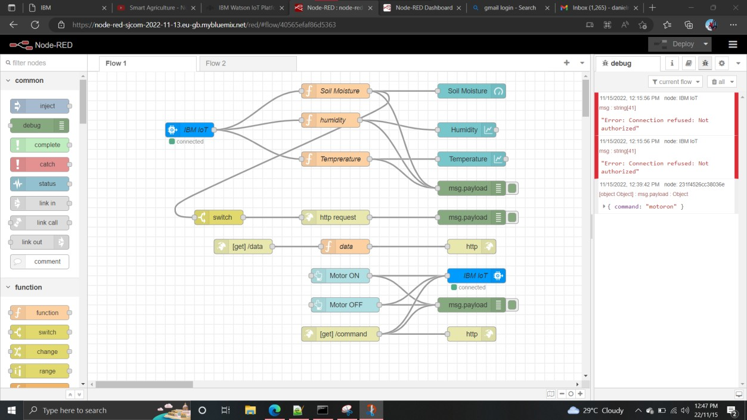

Team Id: PNT2022TMID23510